Test Case: tc005_SPX_Dev5_Crear_Requisicion_Spot_Con_FAD_Tipo_Cobro_Project
Step 1 - Enter username and password and click to button Enter: Credentials Entered
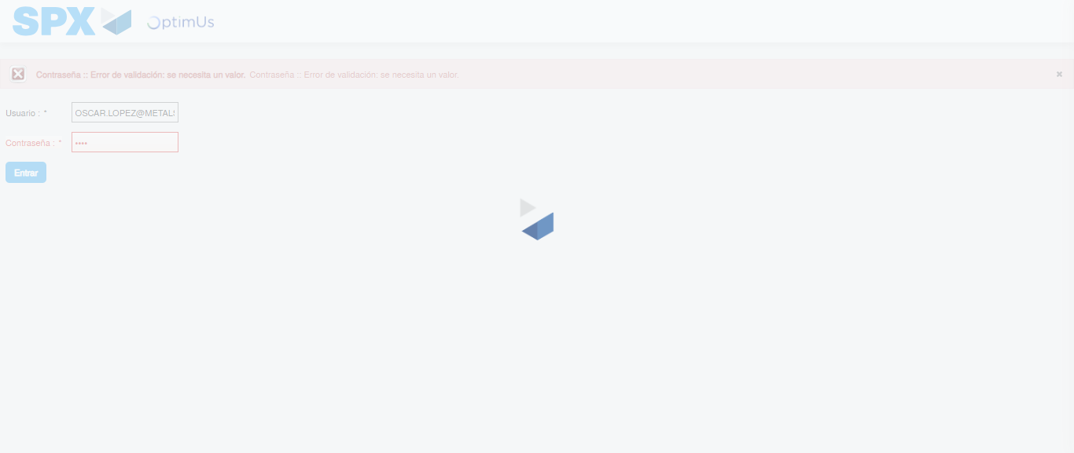Image file-name: QC_Testing-tc005_SPX_Dev5_Crear_Requisicion_Spot_Con_FAD_Tipo_Cobro_Project-1784571865842

Step 2 - Select to UEN and Access to Spot Buy Requisitions : UEN Correctly selected and Correct access
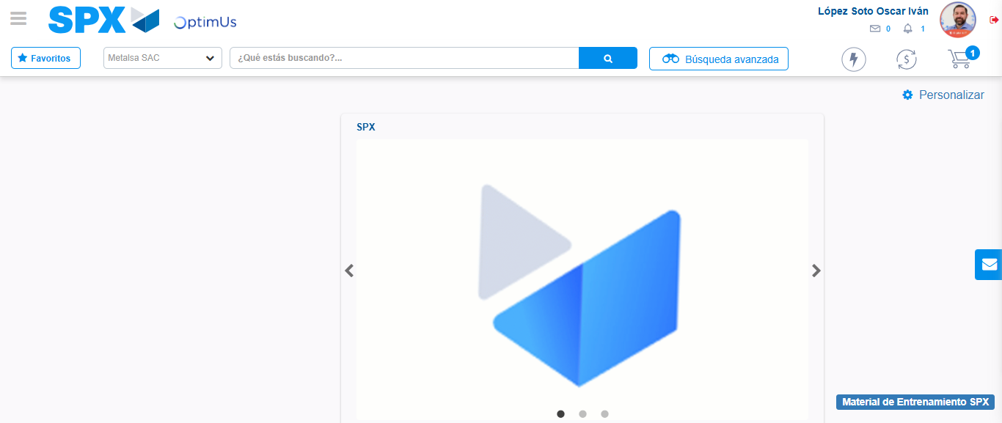Image file-name: QC_Testing-tc005_SPX_Dev5_Crear_Requisicion_Spot_Con_FAD_Tipo_Cobro_Project-1784571939580

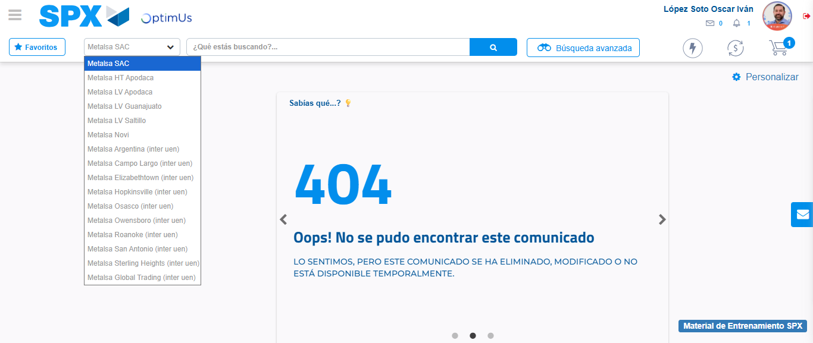Image file-name: QC_Testing-tc005_SPX_Dev5_Crear_Requisicion_Spot_Con_FAD_Tipo_Cobro_Project-1784571942478

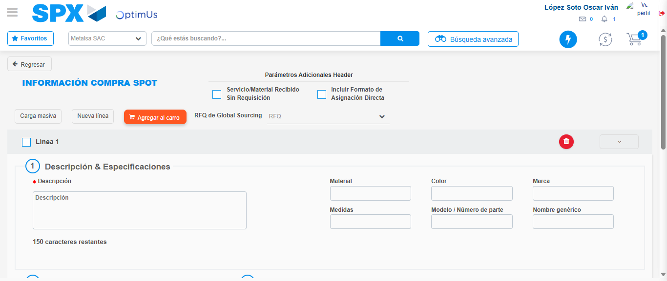Image file-name: QC_Testing-tc005_SPX_Dev5_Crear_Requisicion_Spot_Con_FAD_Tipo_Cobro_Project-1784571969972

Step 3 - Add FAD to Requisition: FAD Successfully Added
Image file-name: QC_Testing-tc005_SPX_Dev5_Crear_Requisicion_Spot_Con_FAD_Tipo_Cobro_Project-1784571970247

Image file-name: QC_Testing-tc005_SPX_Dev5_Crear_Requisicion_Spot_Con_FAD_Tipo_Cobro_Project-1784571970458

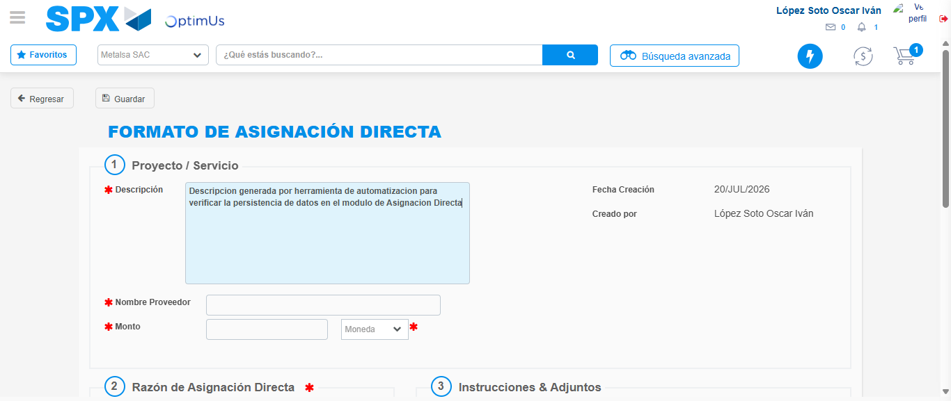Image file-name: QC_Testing-tc005_SPX_Dev5_Crear_Requisicion_Spot_Con_FAD_Tipo_Cobro_Project-1784571973330

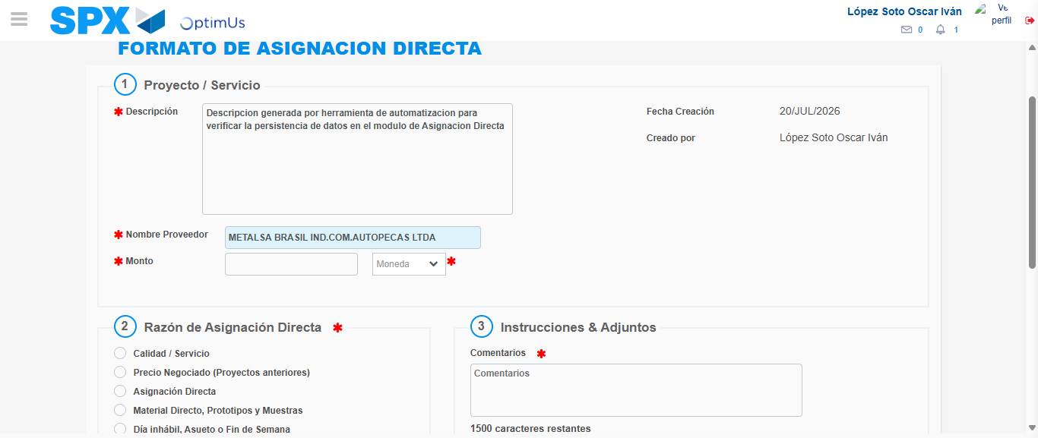Image file-name: QC_Testing-tc005_SPX_Dev5_Crear_Requisicion_Spot_Con_FAD_Tipo_Cobro_Project-1784571979822

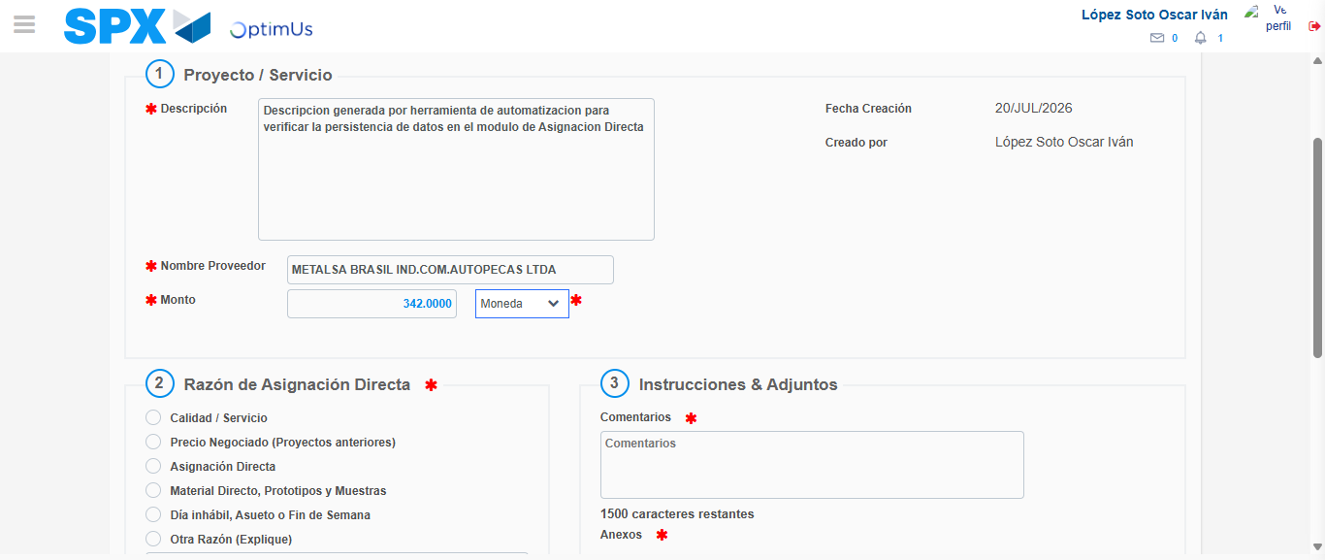Image file-name: QC_Testing-tc005_SPX_Dev5_Crear_Requisicion_Spot_Con_FAD_Tipo_Cobro_Project-1784571980305

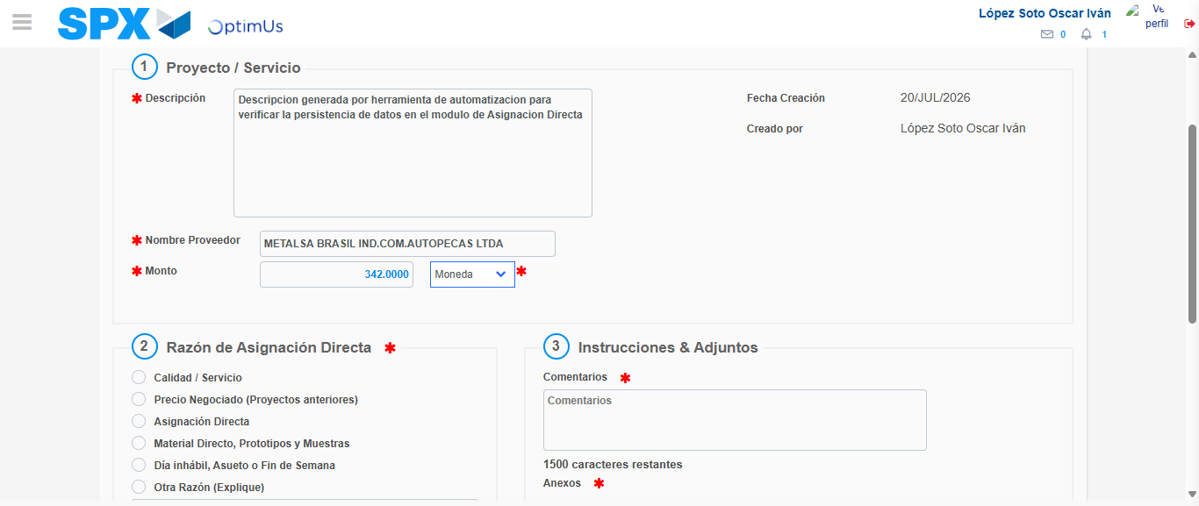Image file-name: QC_Testing-tc005_SPX_Dev5_Crear_Requisicion_Spot_Con_FAD_Tipo_Cobro_Project-1784571980541

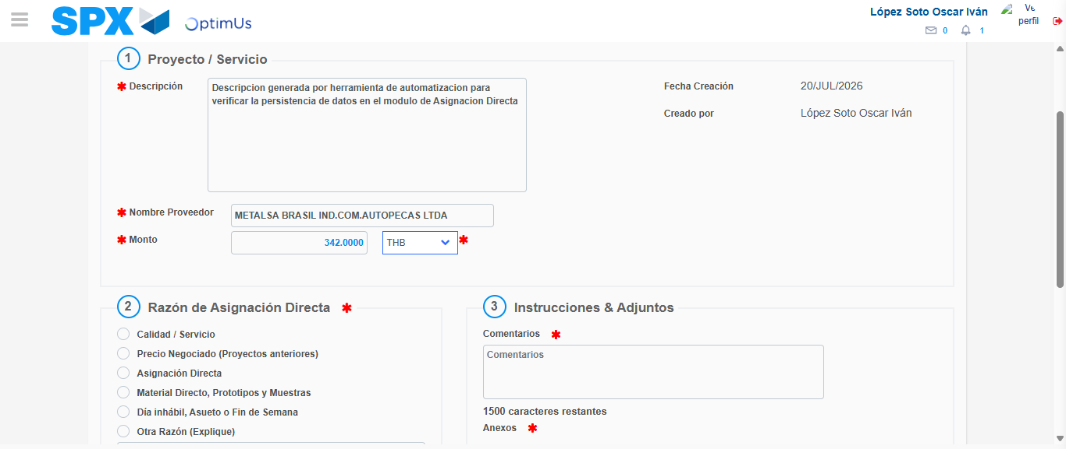Image file-name: QC_Testing-tc005_SPX_Dev5_Crear_Requisicion_Spot_Con_FAD_Tipo_Cobro_Project-1784571980901

Image file-name: QC_Testing-tc005_SPX_Dev5_Crear_Requisicion_Spot_Con_FAD_Tipo_Cobro_Project-1784571981133

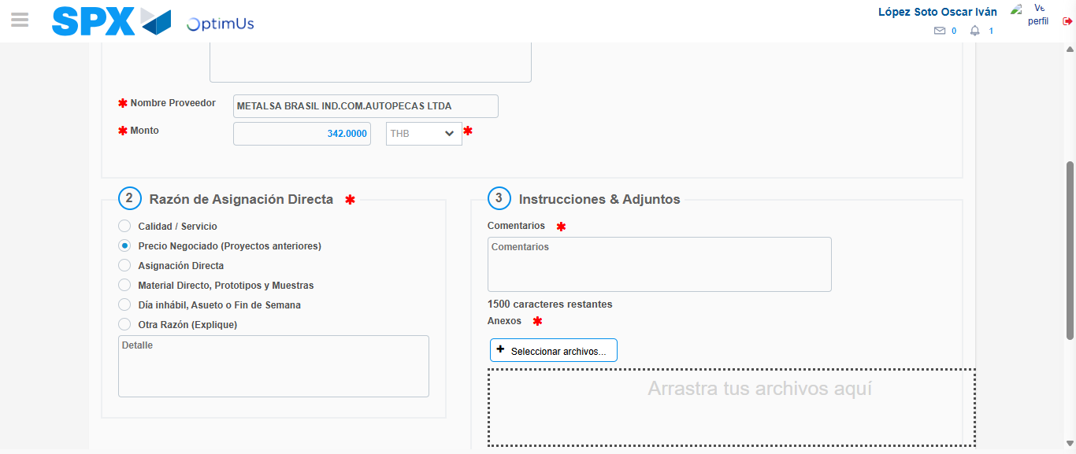Image file-name: QC_Testing-tc005_SPX_Dev5_Crear_Requisicion_Spot_Con_FAD_Tipo_Cobro_Project-1784571982014

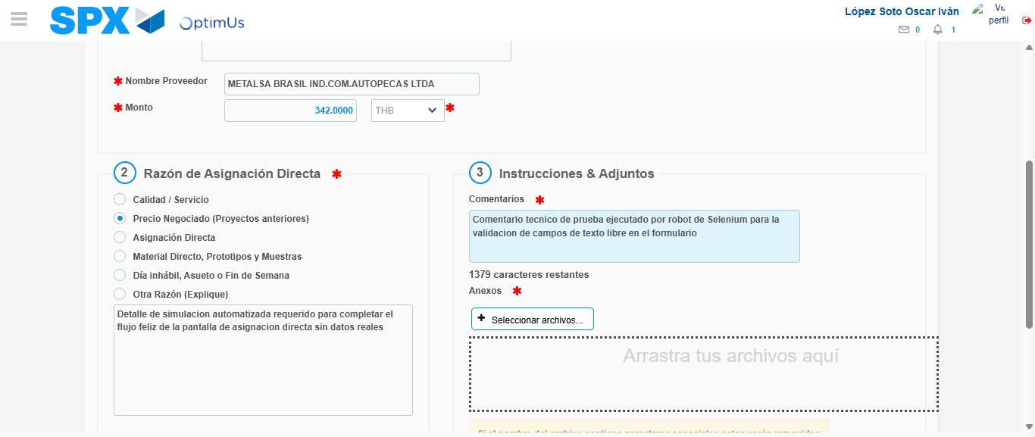Image file-name: QC_Testing-tc005_SPX_Dev5_Crear_Requisicion_Spot_Con_FAD_Tipo_Cobro_Project-1784571993103

Image file-name: QC_Testing-tc005_SPX_Dev5_Crear_Requisicion_Spot_Con_FAD_Tipo_Cobro_Project-1784571993852

Step 4 - Data Capture Spot Buy Requisition: Data captured correctly
Image file-name: QC_Testing-tc005_SPX_Dev5_Crear_Requisicion_Spot_Con_FAD_Tipo_Cobro_Project-1784571970247

Image file-name: QC_Testing-tc005_SPX_Dev5_Crear_Requisicion_Spot_Con_FAD_Tipo_Cobro_Project-1784571970458

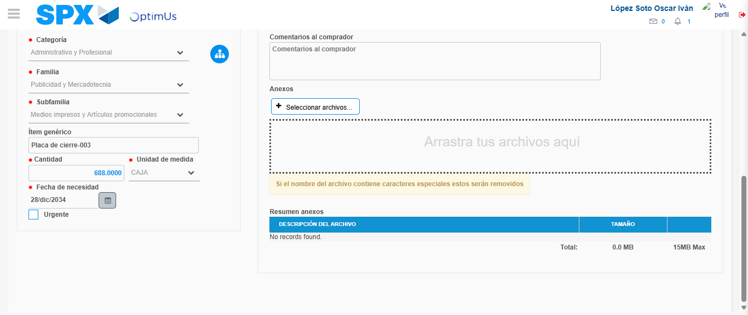Image file-name: QC_Testing-tc005_SPX_Dev5_Crear_Requisicion_Spot_Con_FAD_Tipo_Cobro_Project-1784572007030

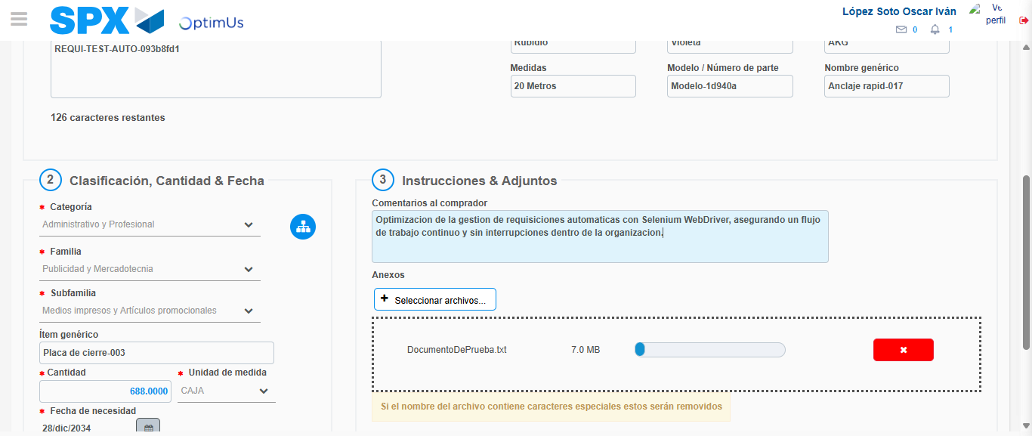Image file-name: QC_Testing-tc005_SPX_Dev5_Crear_Requisicion_Spot_Con_FAD_Tipo_Cobro_Project-1784572007806

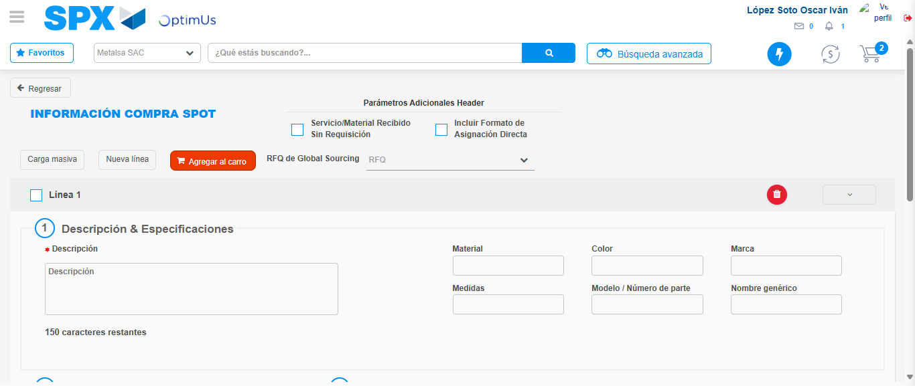Image file-name: QC_Testing-tc005_SPX_Dev5_Crear_Requisicion_Spot_Con_FAD_Tipo_Cobro_Project-1784572015798

Step 8 - Return to Main Page SPX : Return to Main Page SPX
Image file-name: QC_Testing-tc005_SPX_Dev5_Crear_Requisicion_Spot_Con_FAD_Tipo_Cobro_Project-1784571939580

Image file-name: QC_Testing-tc005_SPX_Dev5_Crear_Requisicion_Spot_Con_FAD_Tipo_Cobro_Project-1784571942478

Image file-name: QC_Testing-tc005_SPX_Dev5_Crear_Requisicion_Spot_Con_FAD_Tipo_Cobro_Project-1784571969972

Image file-name: QC_Testing-tc005_SPX_Dev5_Crear_Requisicion_Spot_Con_FAD_Tipo_Cobro_Project-1784572018024

Image file-name: QC_Testing-tc005_SPX_Dev5_Crear_Requisicion_Spot_Con_FAD_Tipo_Cobro_Project-1784572018225

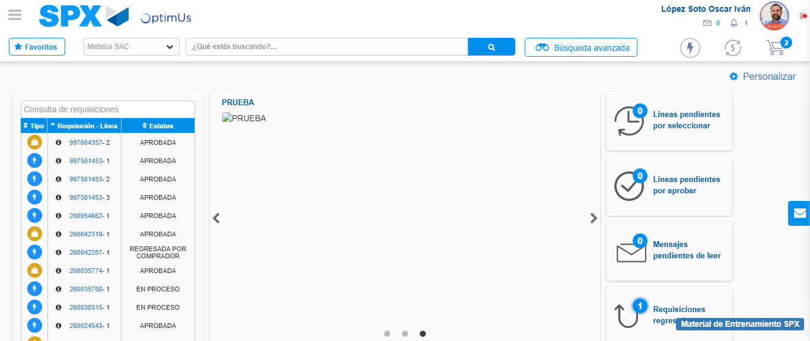Image file-name: QC_Testing-tc005_SPX_Dev5_Crear_Requisicion_Spot_Con_FAD_Tipo_Cobro_Project-1784572039324

Step 9 - Log Out : Log Out SPX
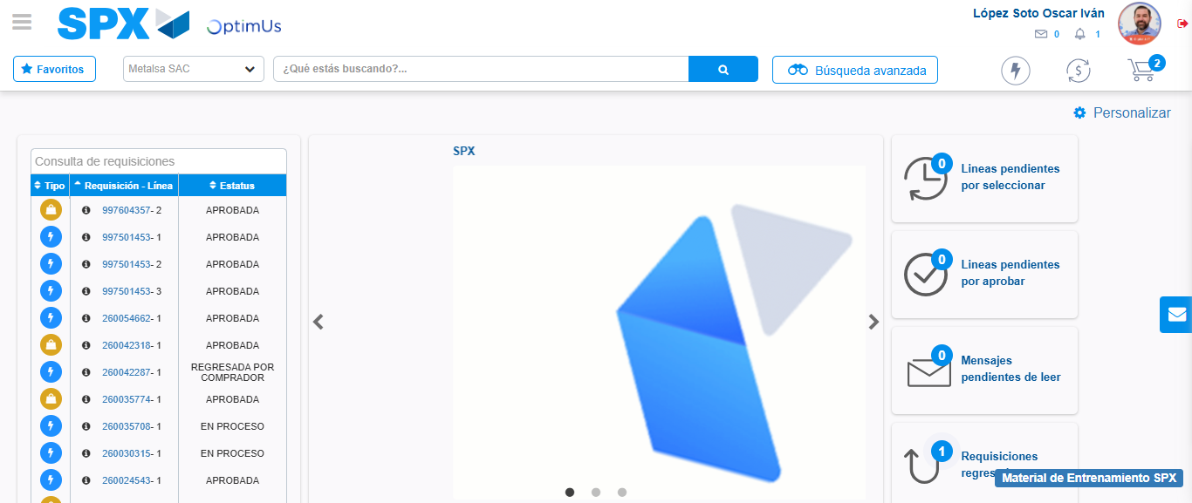Image file-name: QC_Testing-tc005_SPX_Dev5_Crear_Requisicion_Spot_Con_FAD_Tipo_Cobro_Project-1784572039600

